**Part 1**

1. Download the folder [Final_Assignment_Module_12](https://classroom.emeritus.org/courses/8898/files/2299885/download). Provide a screenshot to show that you were able to open the folder in VS Code.

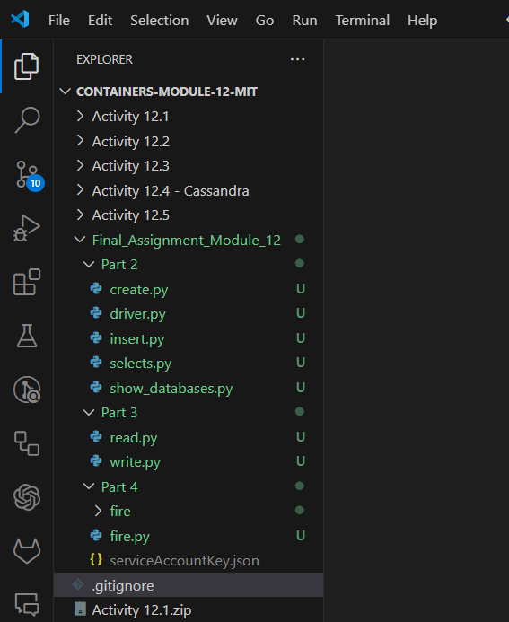

**Part 2**

1. In VS Code, navigate to Part 2 of the folder, which contains the starter file for this part of the assignment. Run the command to initialize the *driver*. Provide a screenshot to show that you successfully ran the command.



1. Open the `create.py` file and modify it to create a database with your choice of title. This database should contain at least three entries. The entries of the database can be about anything you want. They can include something that interests you or something related to your school or work background. Provide two screenshots. The first screenshot should include the code to show which data you defined. The second screenshot should show that you successfully ran the `create.py` file.

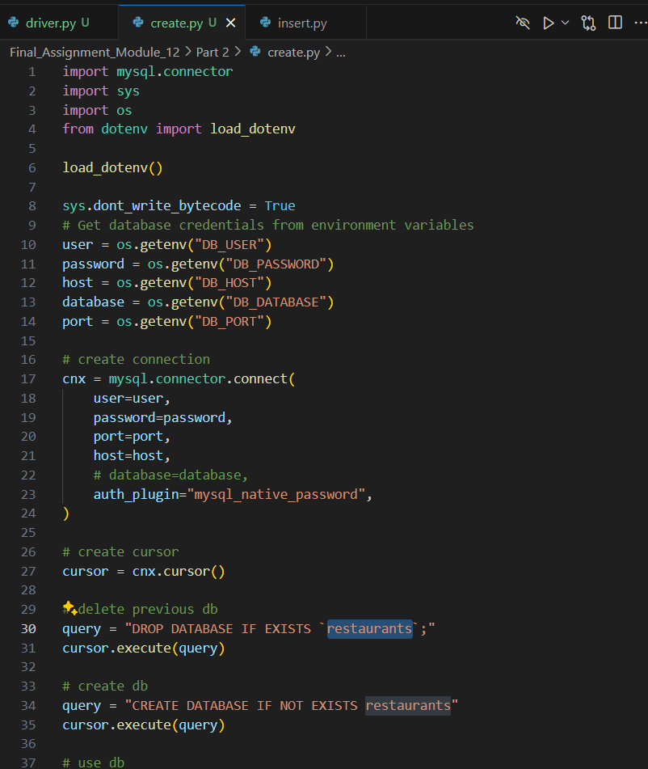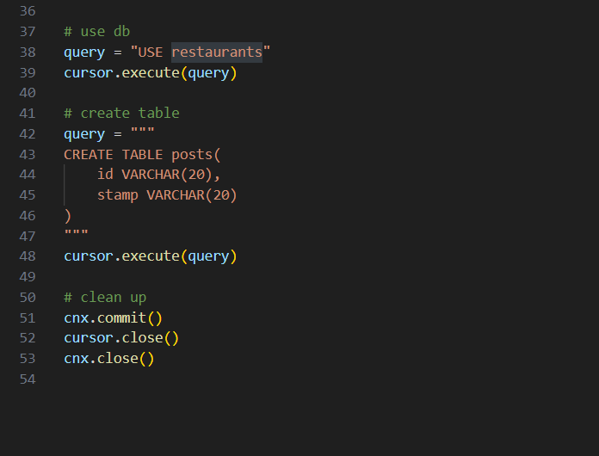

1. In a Terminal window, run the correct commands to insert your data in the database you created so that you can visualize your data correctly in the Terminal window. Provide a screenshot of your Terminal window after running the correct commands. You should see the correct entry in the database.

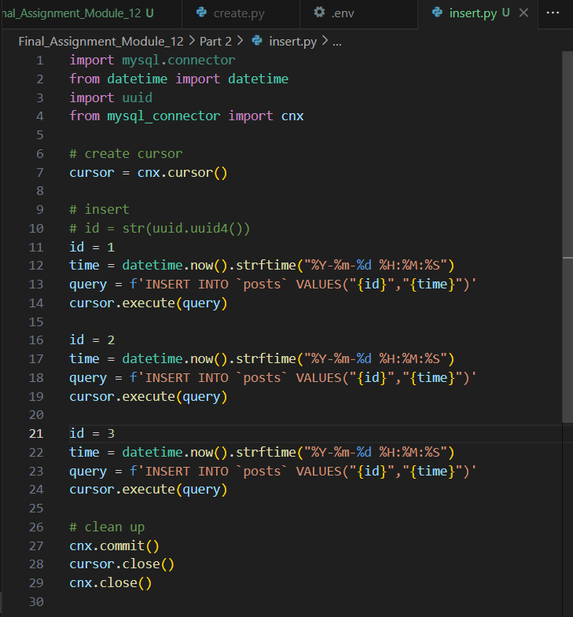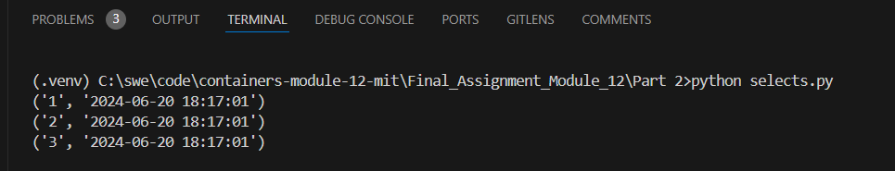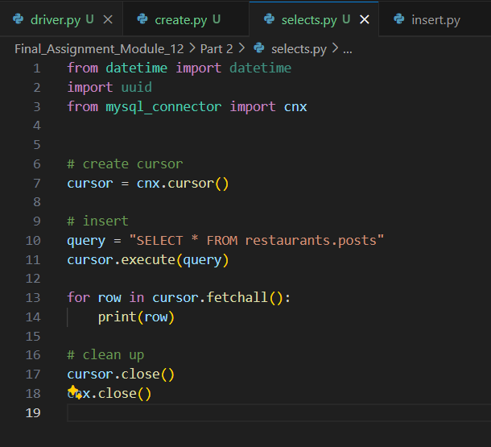

1. Following the steps in Video 12.4, create a Docker *container* named ‘final_assignment’. Use port 3300. Provide a screenshot to show that you successfully created the *container* in Docker.



**Part 3**

1. In VS Code, navigate to Part 3 of the folder containing the starter file for this part of the assignment. Provide a screenshot to show that you successfully ran the command.

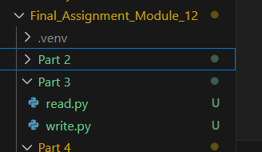

1. Use Redis to create a Docker *container*. Use port 6379 and name your *container* “final_assignment_part3”. Provide two screenshots: The first screenshot should show that you successfully ran the command to create the *container* in your Terminal window. The second screenshot should show that the *container* you just created is active on Docker.

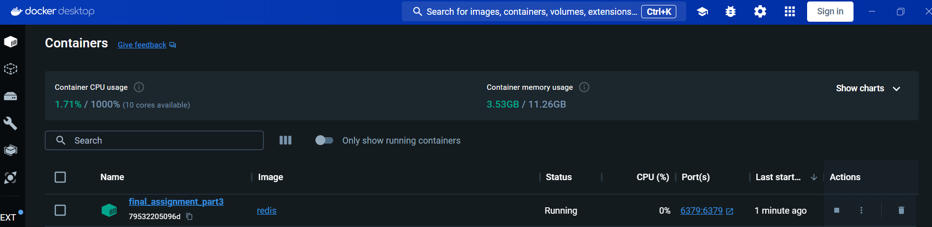

1. Open the write.py file from the folder you downloaded. Use the Redis *method*, mset, to create a *dictionary*, r, with *keys* equal to “Milk” and “Bread” and corresponding values equal to “Lactose” and “Gluten”. Provide a screenshot of the code you wrote.

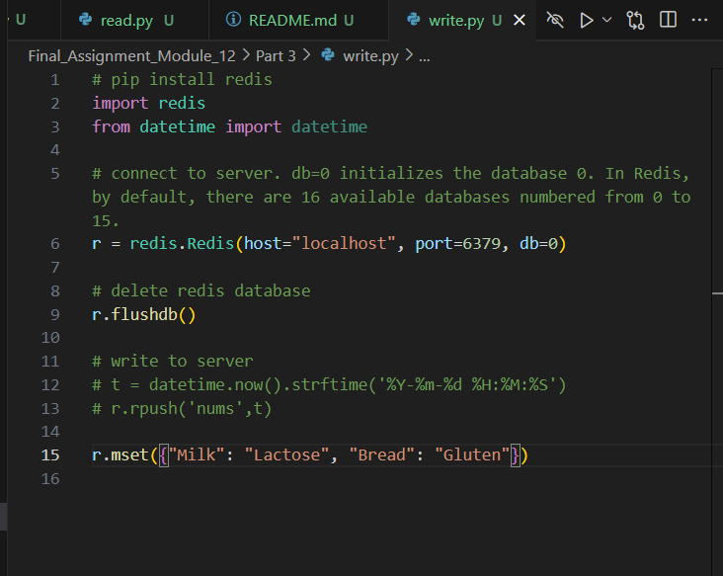

1. Run the write.py file in your Terminal window to show that your syntax does not contain any errors. Provide a screenshot.



1. Open the read.py file from the folder you downloaded. Use the Redis *method*, get, to read all values in r. Provide a screenshot of your updated code.

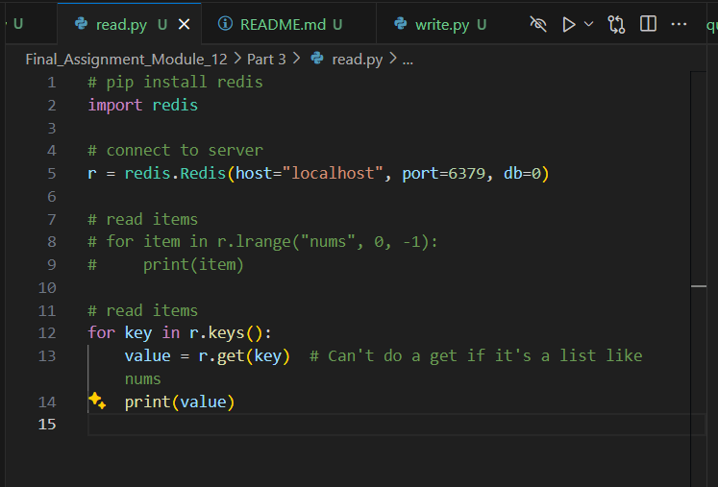

1. Run the read.py file in your Terminal window to show that your code prints the *dictionary* values correctly. Provide a screenshot.

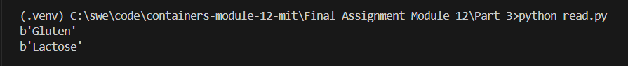

**Part 4**

1. Open a Terminal window and navigate to Part 4 of the folder containing the starter file for this part of the assignment. Provide a screenshot to show that you successfully ran the command.

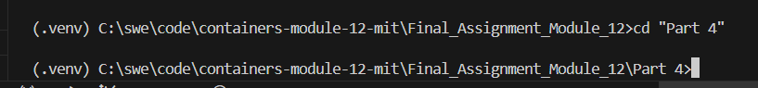

1. In your browser, navigate to [Firebase](https://firebase.google.com/) and create a new project called “Assignment-Module12”. Provide a screenshot to show that you completed this step successfully.

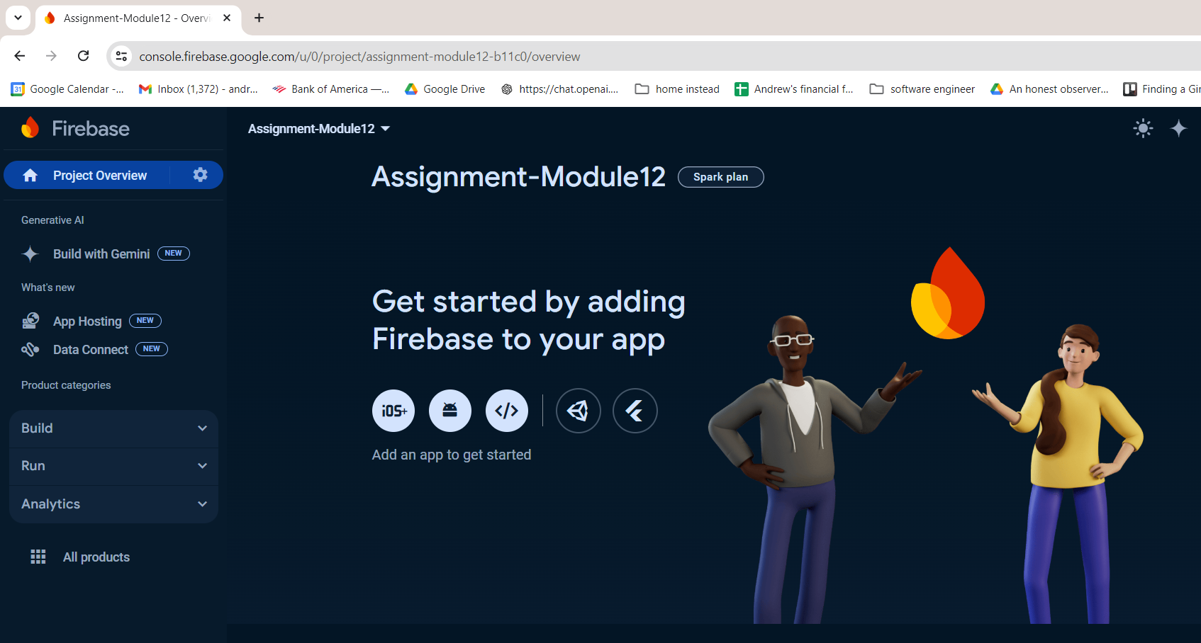

1. In Firebase, obtain permissions to write from Python to your database. Download your own private *key* and copy it into the serviceAccountKey.json file in VS Code. For this step, provide two screenshots: One screenshot should show that you navigated to the correct page in Firebase to obtain the private *key*, and one screenshot should show that you copied the file correctly in the serviceAccountKey.json file. Feel free to blur your private *key* in the screenshots.

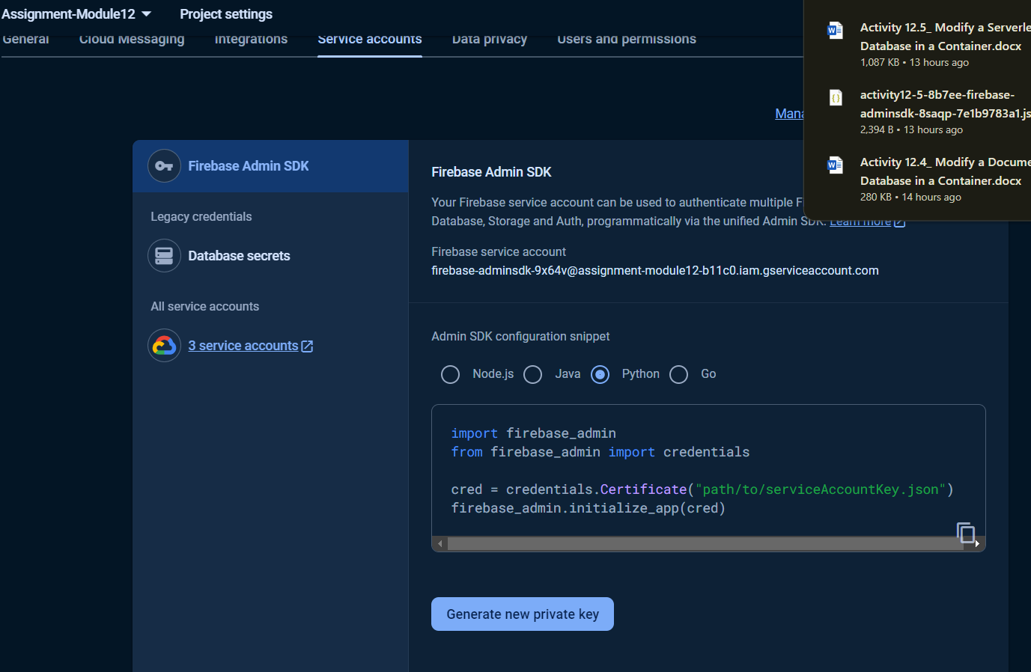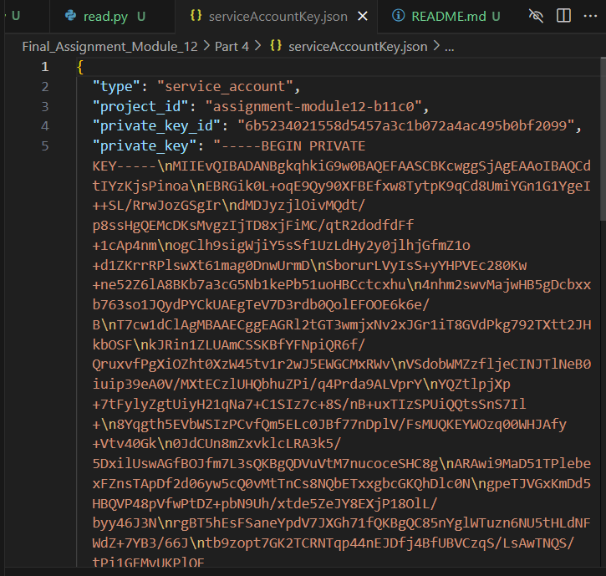

1. Create an empty Realtime database for your project in Firebase. Provide a screenshot to show that you completed this step successfully.

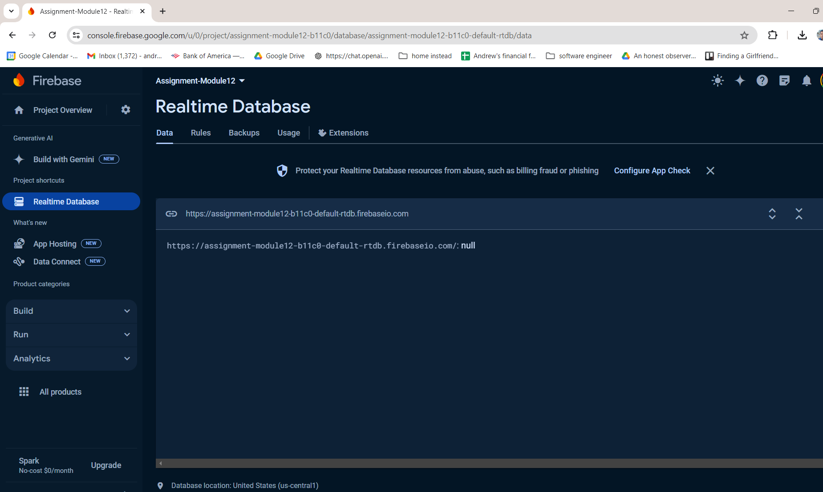

1. Open the fire.py file in VS Code. Update the databaseURL field with the URL you copied. Provide a screenshot to show that you completed this step successfully.

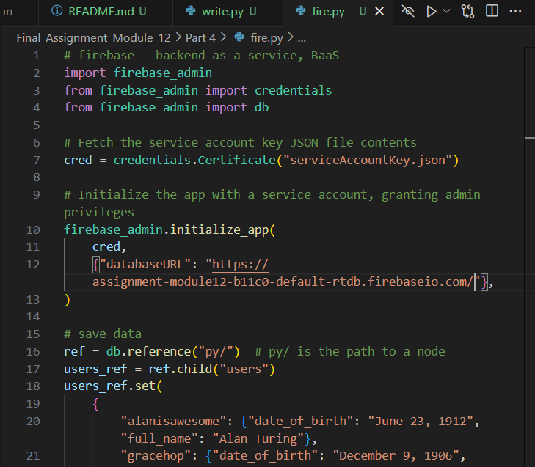

1. Edit the fire.py file to update the two entries in your database. You are free to choose these entries as you wish. They can be about anything that interests you. Update the second entry by adding an extra field. Provide a screenshot to show that you completed this step successfully.

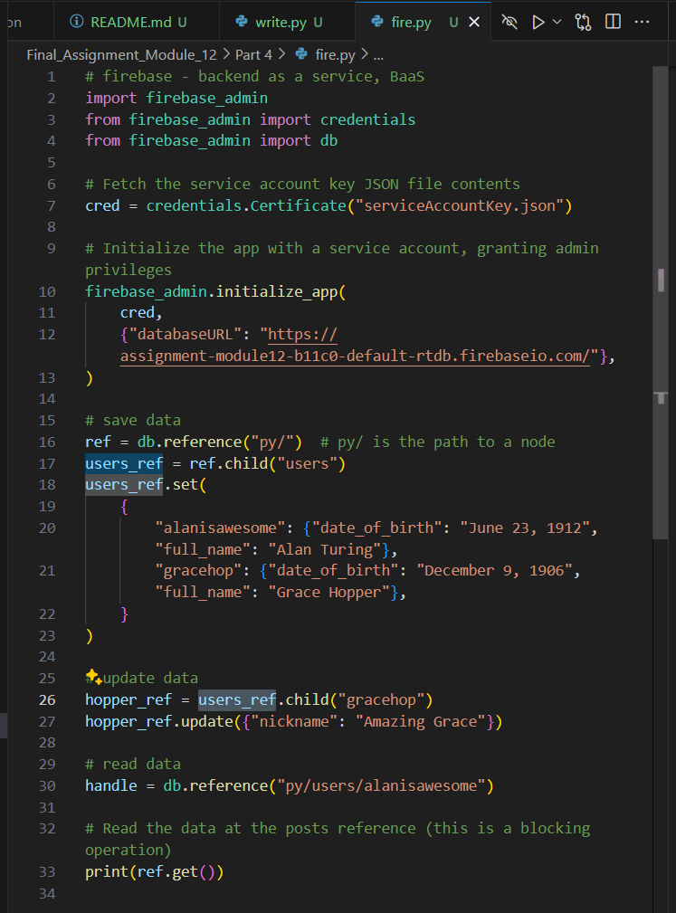

1. In a Terminal window, run the correct command to write to your database in Firebase. Provide a screenshot of your Terminal window to show that the command ran without errors.



1. Provide a screenshot from Firebase to show that your database has been written as expected.

